1. ***A state diagram is provided, should provide a summary of the language recognized by the machine***

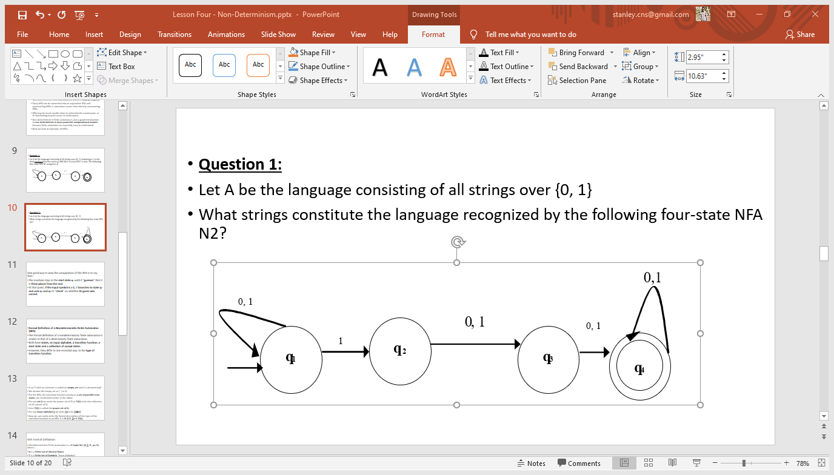

|  |  |
| --- | --- |
| **Possible Transition Paths, input indicated in brackets** | **String** |
| q1 (1) 🡪 q2 (1)🡪 q3 (1) 🡪 q4 (1) 🡪 q4 (1) 🡪 q4 | 11111 |
| q1 (0) 🡪 q1 (1) 🡪 q1 (1) 🡪 q2 (0) 🡪 q3 (1) 🡪 q4 | 011011 |
| q1 (1) 🡪 q2 (0) 🡪 q3 (0) 🡪 q4 | 100 |
| q1 (1) 🡪 q1 (0) 🡪 q1 (1) 🡪 q2 (0) 🡪 q3 (1) 🡪 q4 | 10101 |

The Machine accepts a language whose strings must contain at least a single ‘1’.

1. ***A state diagram is provided and you should*** 
   1. ***describe how the machine transitions on input 000111***

(q2, $) ∈ δ (q1, ∈, ∈)

(q2, 0) ∈ δ (q2, 0, ∈)

(q2, 0) ∈ δ (q2, 0, ∈)

(q2, 0) ∈ δ (q2, 0, ∈)

(q3, ∈) ∈ δ (q2, 1, 0)

(q3, ∈) ∈ δ (q3, 1, 0)

(q3, ∈) ∈ δ (q3, 1, 0)

(q4, ∈) ∈ δ (q3, ∈, $)

* 1. ***Identify the error in the transition table provided for the same machine in the formal description)***

*Error:*

(q2, 0) ∈ δ (q2, 0, ∈)

*Correction Transition:*

(q3, ∈) ∈ δ (q2, 1, 0)

*Other Transitions*

(q3, ∈) ∈ δ (q3, 1, 0)

(q4, ∈) ∈ δ (q3, ∈, $)

(q2, $) ∈ δ (q1, ∈, ∈)